**Updated January 2017**

**Registration Quick Reference Card for Employees/Associates**

Contents

Registration 2

Activate Your Email Address 8

Activate Your Mobile Phone 8

Forgot Your User ID/Password? 9

**Disclaimers:**

* Employee registration does not apply to admin-only services such as General Ledger Interface, ADP Reporting, and Payroll QuickView.
* The registration process outlined in this document does not apply to RUN Powered By ADP® Employee Access®.
* The registration process will vary slightly for employees registering for ADP Retirement Services on the participant website at [www.mykplan.com](http://www.mykplan.com).

|  |
| --- |
| Registration |

Welcome! ADP is committed to protecting your privacy and ensuring that only you can access your personal information. To assist us in meeting that commitment, you must register with us before using our services.

**Before You Begin:** You will need your registration code and the URL to access your ADP service login page. If you do not have this information, contact your organization’s administrator.

Your registration code's format and delivery method depend on your organization's setup:

* You receive a personal registration code (for example, b9a7q6re) in an email from ADP ([SecurityServices_NoReply@adp.com](mailto:SecurityServices_NoReply@adp.com)) or shared by your administrator (verbally or in a secure communication). This code is valid for 15 days from the date of issue.

(Or)

* Your administrator provides a code in the format “CompanyID-companyspecificcode” (for example, CompanyID-200Alabama1943) in a secure communication.

**Security Tip:** To protect your personal information from fraud, be sure to use a known computer or mobile device with a trusted internet connection.

On the login page of your ADP service, click the link to register and create your ADP service account. Follow the instructions on the page.

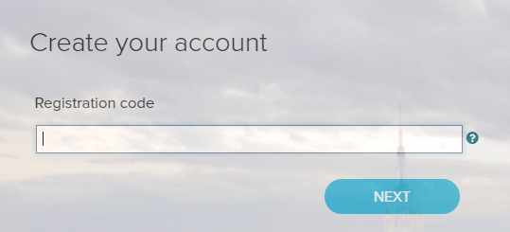

**MM2REGROUP-M2REGROUP**

Enter your personal registration code or your organizational registration code.

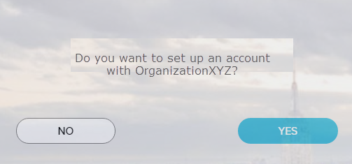

If you do not recognize the name of your organization, select No and start over.

Enter your identity information.

**Important: Based on your organization’s setup, ONE of the options will apply.**

|  |  |
| --- | --- |
| **Option 1**  If you entered an Organizational Registration code, the information requested might vary based on your organization’s setup.  Google™ reCAPTCHA challenge:  Click on the “I’m not a robot” check box and answer a quick challenge and prove you are human. |  |
| **Option 2**  If you entered a Personal Registration code, the information requested might vary based on the information in your record.  Note: Google™ reCAPTCHA challenge is not required when registering with a personal registration code. |  |

Complete the Google™ reCAPTCHA challenge.

This challenge is not required if you are registering with a personal registration code.

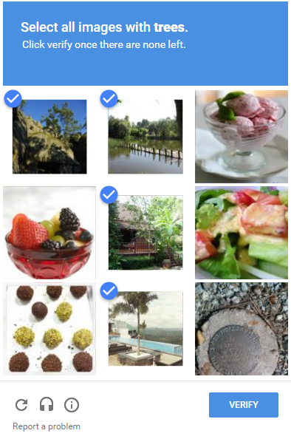

**Sample Challenge**

* **Click on all the images that meet the required criteria.**
* **Select all responses that apply.**

**Need help?**

* **To get a new challenge, click the Refresh icon.**
* **To hear an audio challenge, click the Headphone icon.**
* **To learn more, click the Information icon.**

**Note:** The appearance of the challenge might vary slightly based on your browser and its settings.

|  |  |
| --- | --- |
| **Additional Verification**  Depending on your organization's setup, you may be required to provide additional verification. | |
| **Option 1 – Get and Enter a Code**   * If your email address is **unique** within your organization, and * You have access to the email address displayed during this process.   **How this works:**  You request a code to be sent to your email and enter it in the personal registration code field on this page within 15 minutes.  Don’t recognize the email displayed on this page or have trouble receiving the code**?** Use the option to answer identity questions, if available. |  |
| **Option 2 – Answer Identity Questions**   * If your email address in **not unique** within your organization’s records, or * You do not recognize or have access to the email address displayed on the screen.   **How this works:**  You select a valid response to each question within 30 seconds.  These questions and their answer choices are generated from public records and other commercially available data sources. Your responses are not used for any purpose other than to verify your identity and are not shared with your organization. |  |

Complete the information required on this page to continue.

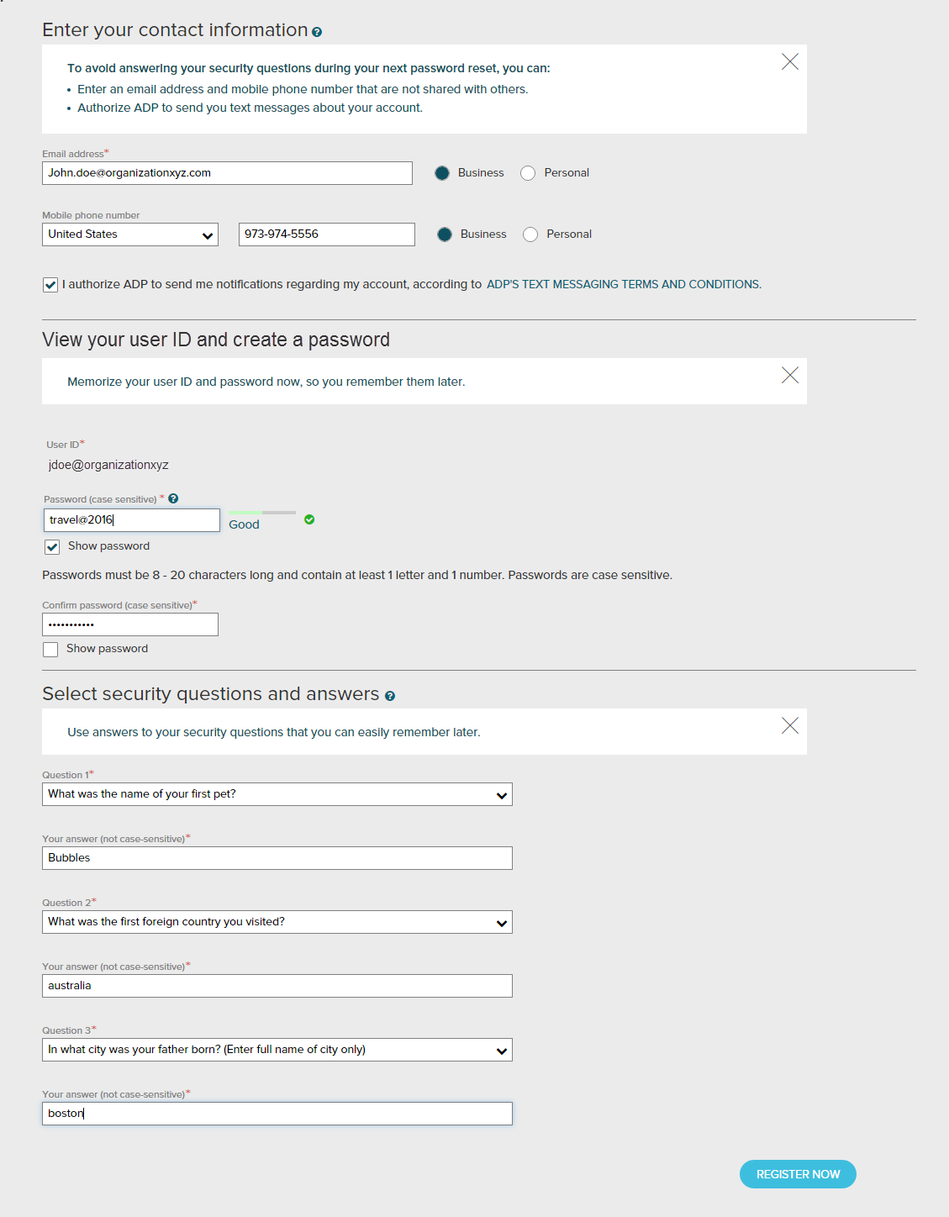

Depending on the ADP services your organization has purchased, the option to create your user ID might be available.

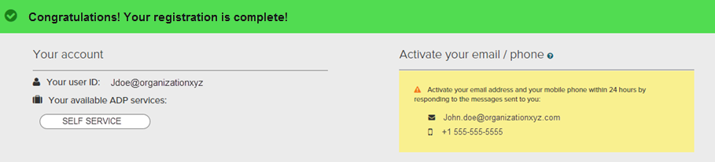

Your registration is complete. You can use your user ID and password to access your ADP service(s).

* Activate your email and mobile phone number to receive important notifications from your organization or ADP.
* Manage your account information to keep it accurate.

|  |
| --- |
| Activate Your Email Address |

During registration, if you provided an email address that is not shared with others in your organization, look out for an activation email from ADP. Click the link in the email you receive from SecurityService_NoReply@ADP.com to complete the activation.

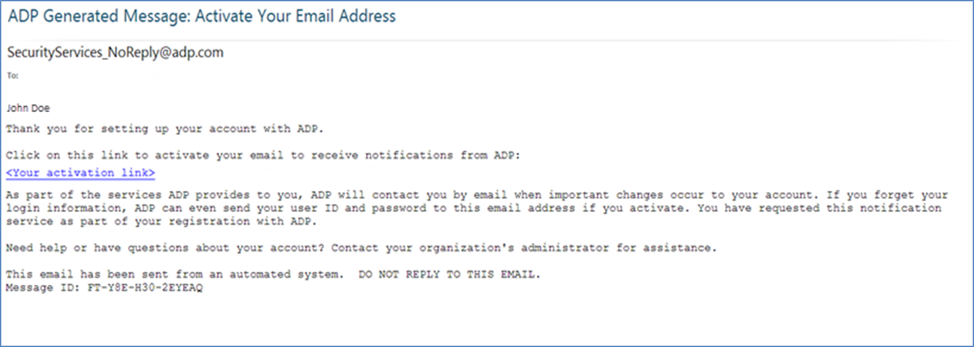

|  |
| --- |
| Activate Your Mobile Phone |

During registration, if you provided a mobile phone number that is not shared with other users in your organization, look out for a text message from ADP. Reply with the code.

**Note:** In some countries, your activation process will differ; so, follow the instructions in the text message to activate your mobile number.

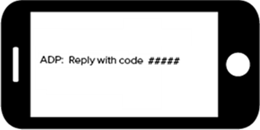

|  |
| --- |
| Forgot Your User ID/Password? |

If you forget your login information, you can use the “**Forgot Your User ID/Password**?” link on your ADP service login page to retrieve your user ID and reset your password. During this process, you will be required to verify that you are the rightful owner of the account to protect your personal information.

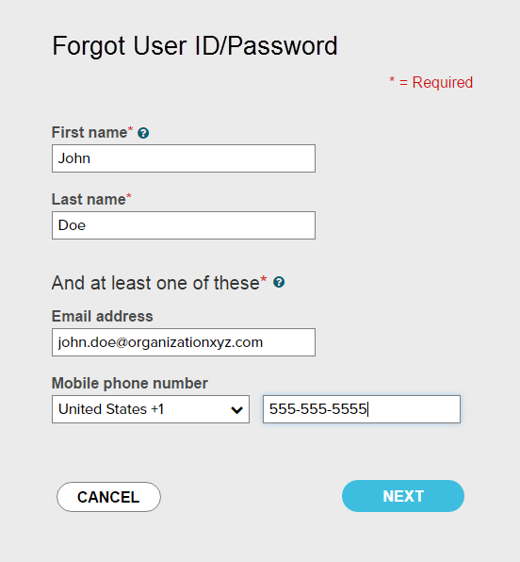

Enter your first name and last name exactly as they exist in your organization’s records.

Enter an email address and/or mobile phone number associated with your account.

Upon successful verification of the information that you entered, your user ID will be displayed.

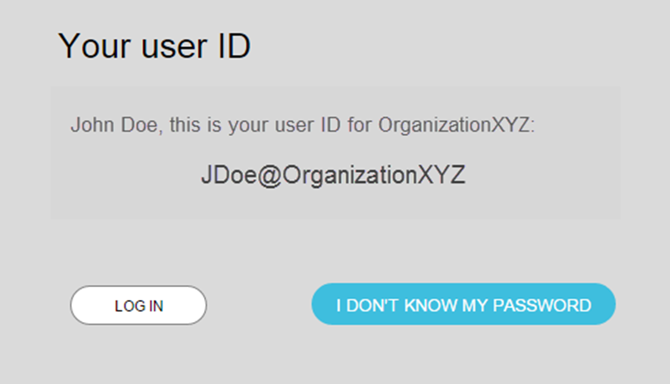

Click I DON’T KNOW MY PASSWORD to reset your account password.

The process will be different for administrators / practitioners.

Congratulations! You have successfully retrieved your user ID of your ADP service account.

To Reset Your Password

Select the “I don’t know my password” option. If you have an email address and/or mobile phone number that is not shared with others in your organization, you can receive and enter a security code.

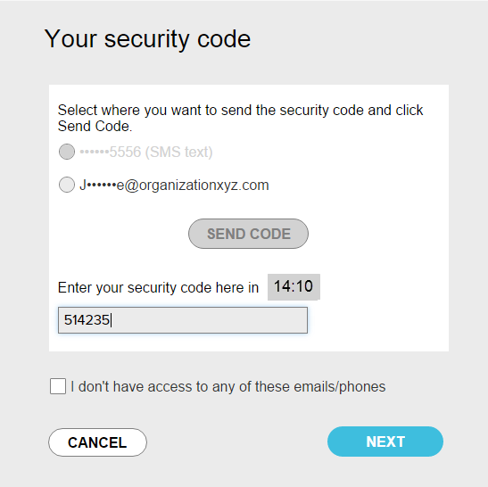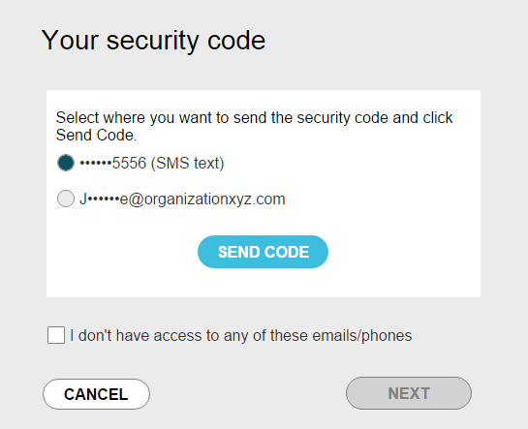

…and enter it here within 15 minutes.

Send the code to your email or mobile phone…

If you don’t have access to your email/phone or you share your email address and/or mobile phone number with others in your organization, you will be prompted to answer security questions instead.

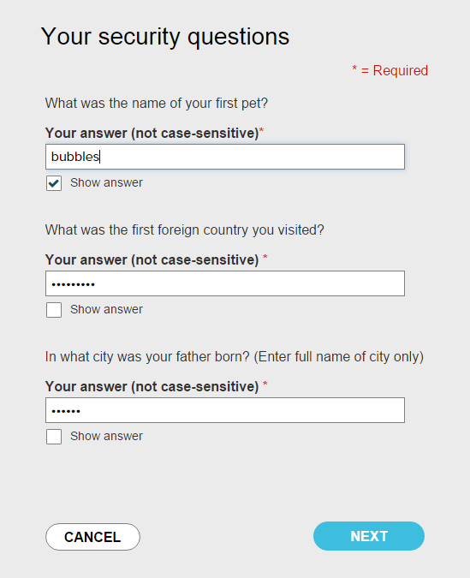

Click Show answer to reveal your answer briefly.

Upon successful verification of your security code or your security answers, you will be prompted to enter and confirm your new password.

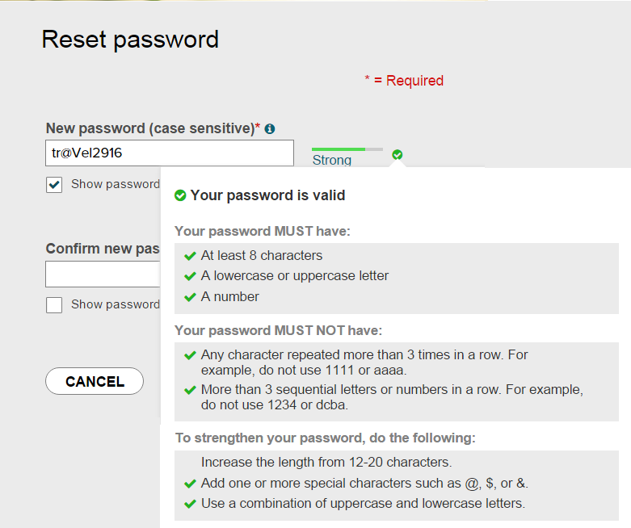

Click to see how well your password meets the requirements and how to make it stronger.

Click Show password to reveal your password briefly.

Congratulations! You have successfully retrieved your user ID and reset your password of your ADP service account.