

To access the Vision Learning Management System…

* Go to http://www.GracehillVision.com/M2
* Login with your assigned Username and Password. *(Username is your first name initial followed by your full last name. Your password is first name initial, last name initial followed by the last four digits of your SSN).*

***Example: Michael Sample SSN: 111-22-3344***

*Username: msample Password: ms3344*

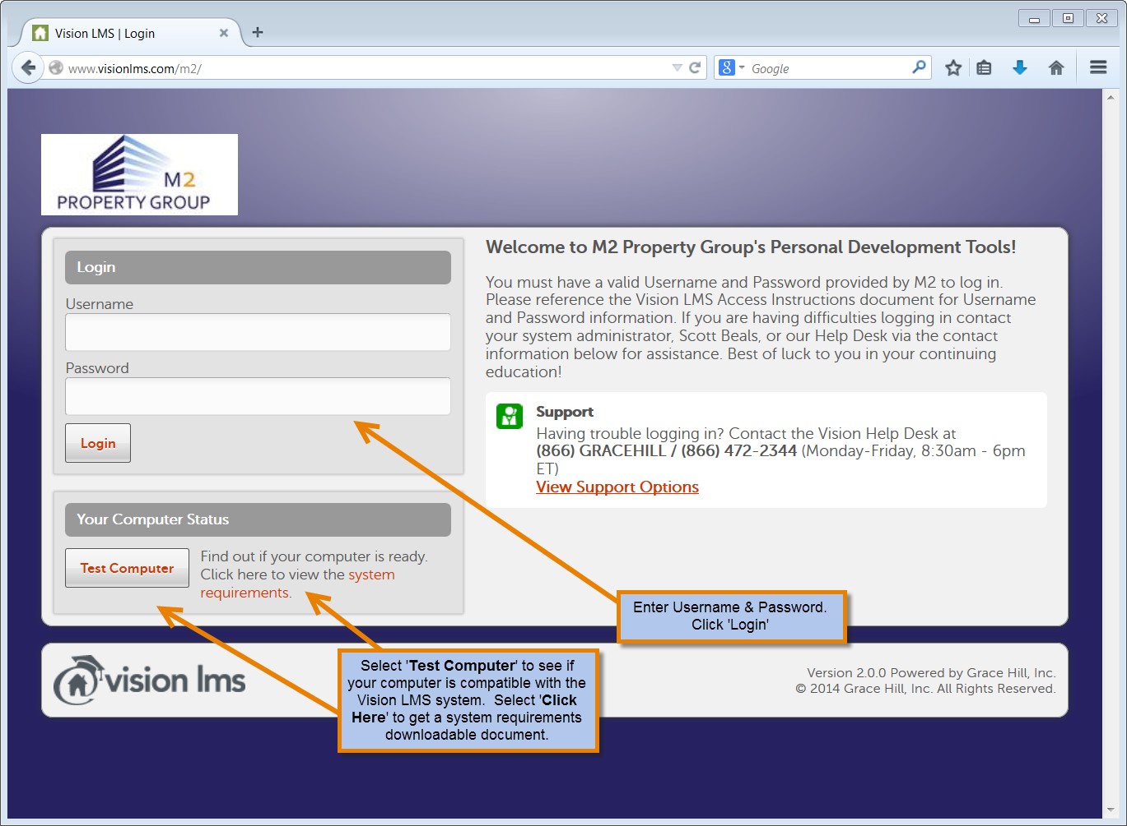



Once you are logged into Vision, on the **‘My Dashboard’** tab, you will see **Performance**, **Compliance** and **Training Calendar**.

* **Performance** shows your course completion information: number of completed courses, total training hours, average score and your average score compared to your Location, Position and Company. You can select the **‘Course Types’** dropdown to show comparisons between the different types of training your company offers.

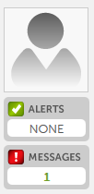

Roll your mouse over the silhouette image and click on ‘**Edit Picture’** to upload your own personal photo.

Any training **‘Alerts’** you receive via email will appear here. If a number appears, click on it to view the alert.

**‘Messages’** sent internally from your company will appear here. If a number appears, click on the it to view the message.

* + Place your mouse to the right of your name to view the ‘**Edit Profile’** option. Click on **‘Edit Profile’** to select your landing page if more than one LMS application is assigned to you; add an Alternative Email for your Email Alerts to be delivered to a secondary email address; and enter your Grace Hill User ID and Password for the [www.gracehill.com](http://www.gracehill.com/) website.
* **Compliance** shows your Top Five assignments in order by due date and your individual compliance percentage in meeting your assignments. You can launch and take any of the assignments by clicking on the assignment name under the **‘Title’** column. All additional assignments can be accessed from the **‘My Assignments**’ tab.

By rolling your mouse over the icon located in the **‘Type’** column, you can determine what type of assignment is required.

* **Training Calendar** highlights dates when you have an assignment due. Click on the highlighted date and all assignments due on that particular day will be visible.



Under **‘My Assignments’** you will see all of your assignments along with deadline dates for completion and the Status of the assignment.

* By rolling your mouse over the icon located in the **‘Type’** column, you can determine what type of assignment is required.
* Clicking on the assignment name in the **‘Title’** column provides you with Assignment Details which include: Title, Training Type, Training Hours, Description and Requirements.
  + Requirements indicate the action you must take to complete your assignment. Requirements will be shown in the order they must be completed and may include: Enrollment Options, Pre-Test, Content and Post-Test.

Requirement action is not available.



Action has been taken and may be changed.

Requirement action is ready. Click to view additional details, resume or complete. Requirement has been completed successfully.

Assignment is complete.

All workbooks and other downloadable resources can be accessed by clicking on:



Add Instructor-Led and Webinar Learning Object due date reminders to your external calendar by clicking on:



Be sure to change the time to your current time zone when saving the event to your external calendar.

If multiple versions are available for a course (such as Spanish or state specific options) simply choose the  button after clicking on the assignment title and you will be given the option to select the appropriate version of the course for you.

***NOTE****: When exiting an online course prior to completion, simply choose* ***‘Exit’*** *in the bottom right corner of your screen. The system will prompt you to access your last location upon your return.*

* Dates in the **‘Due By’** column indicate the assignment deadline as established by your company.

* Today or Overdue * Due within 1-14 days * Due within 15-30 days * Due 31+days

* The **‘Status’** column indicates your progress for that assignment by displaying Not Enrolled, Not Started or In Progress.

Some of your assignments may be part of a Learning Path. Learning Paths are made up of multiple Learning Objects grouped together in a badge. Upon completion of a Learning Path, the badge will show under your My Achievements tab. Some Learning Paths may be recurring and show due to be completed again.

To see what Assignments make up a Learning Path, click on the Learning Path badge icon under **‘My Learning Paths’**. The assignments will display and can be accessed under the Learning Path and also with your other assignments under **‘My Assignments’**.

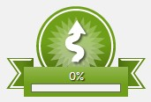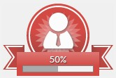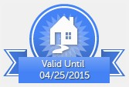

As assignments are completed, the percentage meter will indicate your progress toward full completion of the Learning Path. If the Learning Path is recurring, it will indicate the validation term.



Under the **‘My Library’** tab, you will see a **‘My Bookbag’** tab and individual tabs for different learning object types. The titles listed under these types have not been assigned to you but are available at any time should you choose to complete additional training on your own.

* Under each learning object type tab, you will see an **‘Add’** button next to each library item available to you. Selecting ‘**Add’** will place the library item in your Bookbag. This allows you to view the information and complete the training at your convenience.
* Any learning object added to **‘My Bookbag’** can be removed after completion or once it has been viewed by clicking on the **‘Remove’** button.



Under the **‘My Achievements’** tab, you will find a record of all the training you have completed to date. The transcript can be printed or emailed to an individual of your choosing by clicking on the appropriate button at the top of the screen.



* When available, certificates of completion may also be printed or emailed by clicking on the appropriate button to the right of the title.

Print  Email



Click on this icon to access [www.gracehill.com.](http://www.gracehill.com/)

 Click on this icon to view support options internally for your company and for Grace Hill.  Click this icon to log out of Vision.